Learn more about Excel, Python, JavaScript:
Lynda.com – go to https://skokielibrary.info/resources/online-training-tutorials/ and click on Lynda.com. Create a free account with your library card number and a password of your choosing. Enter a search term in the search bar and find an interesting class.

Learn more about Excel:
Goodwill Free Learning – go to https://www.gcflearnfree.org/topics/office2016/ and scroll to Excel 2016.

Books
Data At Work by Jorge Camoes, 2016, Newriders Accompanying website with data: DataAtWorkbook.com

Statistical Analysis with Excel for Dummies, by Joseph Schmuller, PD, 2016, John Wiley and Sons

Websites
https://public.tableau.com Free version of Tableau. Open data and explore it with Tableau Desktop Public Edition. Drag & Drop. Create stunning visualizations with ease

https://www.r-project.org/ R is a free software environment for statistical computing and graphics. It compiles and runs on a wide variety of UNIX platforms, Windows and MacOS.

https://www.adobe.com/products/illustrator.html Vector graphics software lets you create logos, icons, drawings, typography, and illustrations for print, web, video, and mobile. Patrons with a Skokie Library card can use the DML, which has full versions of Adobe CC, which includes Illustrator.

https://www.python.org/ and https://python-graph-gallery.com/all-charts/ - Python, along with Javascript and other programs, help create amazing internet carts.

https://www.wordclouds.com/ to make a word cloud.

Best data for Science
census.gov/ US Census bureau
wonder.cdc.gov/ Center for Disease Control database
www.cdc.gov/nchs/nvss/mortality/gmwk23r.htm CDC mortality tables
ebird.org/science download bird sightings by area and by time.
www.officialcharts.com popular music tracker
www.imdb.com/chart/moviemeter most popular movies
trends.google.com/trends/?geo=US See what is trending on Google
www.sports-reference.com/ for popular professional sports.

Best example charts for Science
https://www.opportunityatlas.org/ - Which neighborhoods in America offer children the best chance at a better life than their parents? From the Hidden Brain podcast, https://www.npr.org/2018/11/12/666993130/zipcode-destiny-the-persistent-power-of-place-and-education

https://atlas.media.mit.edu/en/ The Observatory of Economic Complexity

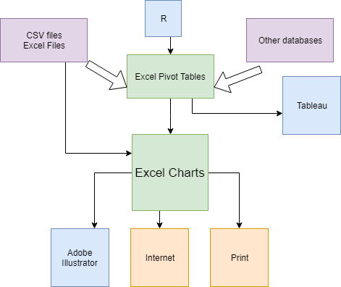
The Library has Office 2016 on all public computers – learn Excel here!

In the DML, there is Adobe CC, which contains Illustrator, and it is available for Skokie Library cardholders.

In the Computer Classroom, some of the PCs have Adobe Photoshop Elements, which can help turn simple charts into infographics.

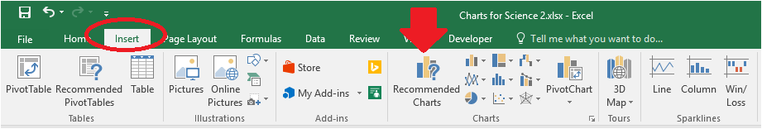

To create an Excel chart:

- Select the data
- Go to the Insert Tab > Chart

