Using your phone internationally
1. Using Airplane Mode and Wi-Fi (aka what you need to turn off on your iPhone when you’re abroad)
This section will help you completely avoid international charges on your iPhone bill. Why is this important? If you don’t freeze your account (Section 8) and your phone happens to pick up service in foreign countries, you might be tempted to use apps or answer calls, and that will skyrocket your bill. SKY. ROCKET. Your bill. International charges will be applied to your account, and the sight will not be pretty.
Avoid international charges, yet still enjoy the apps on your phone by connecting to Wi-Fi.
You don’t need to do anything special to your phone before you go abroad. Afteryou arrive in your destination country:
How to Turn on Airplane Mode and Use Wi-Fi at the Same Time (Yes, you can).
Swipe up from the home screen to access your control center:
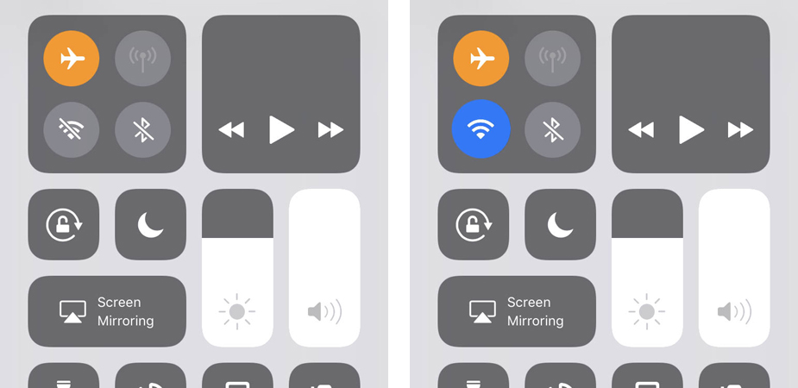
Turn Airplane Mode ON, then turn Wi-Fi ON.
As long as Airplane Mode is ON, you won’t be charged for data. To double triple make sure you won’t be charged for data, do this:
- Settings –> Cellular –> turn Cellular Data OFF
Any apps that function on Wi-Fi (Facebook, Instagram, Twitter, Mail, Voxer, etc.) are accessible as long as you are connected to Wi-Fi. Go to town.
Turning off Airplane Mode and Cellular Data essentially turns off your phone number and the data you normally pay for. This means, you cannot receive or place regular phone calls or SMS messages (iMessage excluded, see next section). Also, you can’t access anything that needs Wi-Fi to function if you’re not connected to a Wi-Fi signal.
No Control Center? Using Airplane Mode and Wi-Fi for Dummies:
Step 1: In your Settings, turn Airplane Mode ON (make sure the little airplane icon is highlighted). This ensures you will not use any data or incur any unexpected international charges.
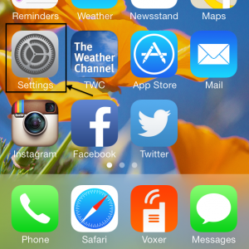
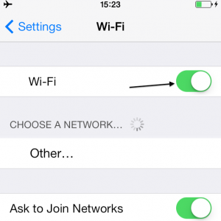
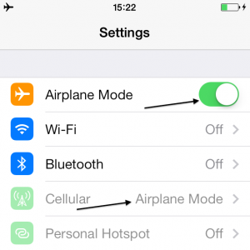

Step 2: In your Settings, select Wi-Fi, and turn your Wi-Fi ON. Airplane Mode automatically turns Wi-Fi OFF, so you will want to go in and turn it back ON. Your only chance to use your phone’s Wi-Fi-capable apps and functions will be when you are connected to Wi-Fi. If you aren’t picking up any free signals, you’ll want to head to a coffee shop or your hotel to find one.
Step 3: To connect to a Wi-Fi signal, go into your Settings, select Wi-Fi, and select a network. If your hotel or a restaurant provides Wi-Fi that takes a password, you’ll need to get the password from them, then select that network and type in the password to connect.
2. Using iMessage and FaceTime Overseas (for free)
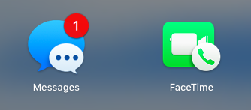
Connect your iPhone to Wi-Fi, with iMessage and FaceTime turned ON and activated:
- Settings —> Messages —> make sure iMessage is ON
- Settings —> FaceTime —> make sure FaceTime is ON
- If you have been switching SIMs and phone numbers around recently and iMessage isn’t activating on your iPhone, restart your phone and try again.
iMessage and FaceTime work through your Apple ID if they can’t use your affiliated phone number. Meaning, in your Settings —> Messages —> Send & Receive, you will see all options you have to reach people through iMessage, and you can use your email address when your phone number is frozen or unavailable (i.e. perhaps you switched out your SIM). Your friends at home might see an email address instead of your phone number when you send a text, but it still works.
As long as Airplane Mode is ON, or if your Cellular Data is OFF, you won’t be charged for using these services. If Airplane Mode is not on, and your Cellular Data is turned on, FaceTime will charge as Data, so be careful.
Using iMessage and FaceTime for Dummies:
- Facetime: A nice way to chat with family and friends back home as long as they have iPhones and are awake at the same time as you! (Mind the time zone!) Open your Contacts, select the person you want to FaceTime, and hit the video icon in your options. Alternatively, open your FaceTime app (looks like the green one above), on the top select Audio or Video, then type the name of the person you’d like to chat with, they should show up in a list, tap their name to place the call. If they don’t have an iPhone, it won’t work.
- iMessage: Yes, iMessage functions on Wi-Fi (between iPhones only), so you can text all you want with others who also have iPhones and iMessage, even overseas! You don’t have to do anything special to make iMessage work (it should already be turned on in your Settings), your phone already knows what to do. Simply text anyone else with an iPhone. If you aren’t sure who has one, you can look back in your texts. Anyone you text that has blue text bubbles has an iPhone, anyone with green text bubbles does not.
3. Best Apps for International Texting and Calling (for free)
All of the following listed app functions are free on Wi-Fi. Please note that it is necessary for each user to communicate through the same app (i.e. you can’t send a WhatsApp message or place a call to someone who doesn’t have WhatsApp).
WhatsApp: Most popular app outside the US for texting and phone calls. Download it and activate your phone number with it. Even if you freeze your phone number or switch out the SIM, you can still opt to continue using WhatsApp with the original number that you connect to it. The only time this won’t work is if you give up your number and someone else starts using it. (Avoid that with Tossable Digits). Functions: texting, sending images and videos, voice messages, video calls, audio calls.
iMessage: Refer to previous section. Functions: texting, sending images and videos. (iPhone to iPhone only).
FaceTime: Refer to previous section. Functions: audio and video calls. (iPhone to iPhone only).
Facebook Messenger: Messenger has come a long way. Functions: texting, sending images and videos, and placing voice and video calls.
Voxer: One of my favorite apps for keeping in touch with my best friends and family. It’s like a walkie-talkie app. Functions: texting, sending images and videos, voice messages up to 15 minutes long.

Source: https://www.thebudgetmindedtraveler.com/iphone-abroad/

