Travel Hacking
Caitlin Myers • Assistant Information Services Supervisor • cmyers@skokielibrary.info
Flights
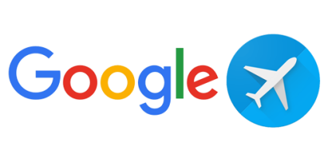
Google flights will compare hundreds of airlines, no preference to airline affiliations.
Momondo will compare hundreds of airlines, no preference to particular airline affiliations, but does not show as many airlines as Google flights. However, Momondo gives you the option to choose which ticket class you’d like and if a direct flight is preferred. Best for international flight comparison.
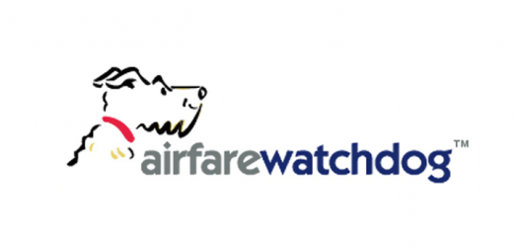
Airfare watchdog will alert you of price updates to let you know when the best price for your flight will pop up.
Accommodation

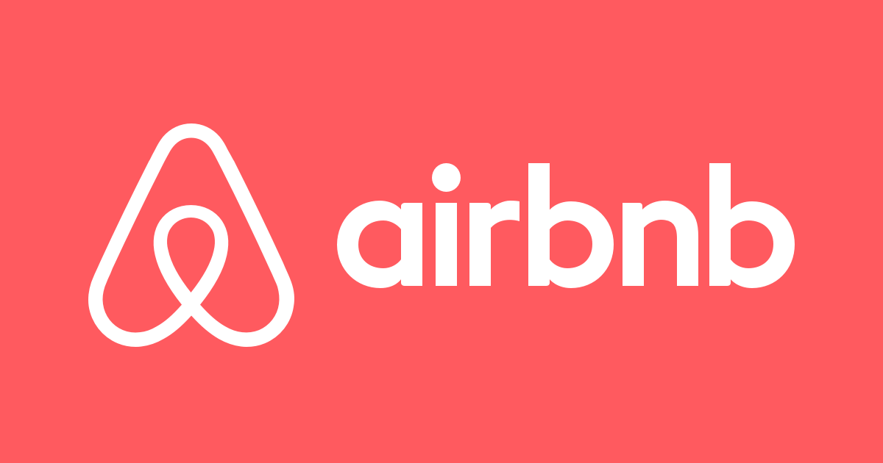
Airbnb is an alternative to staying in a hotel or hostel. Stay with other guests and make friends or rent an entire apartment or house.

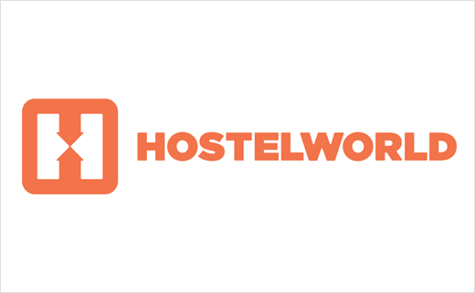
Hostelworld compares hostels in your area on a ten point scale. This is based on cleanliness, friendliness, value for money, security, and atmosphere.

Couchsurfing allows you to stay with a host for free. The host is not obligated, but often will show you around the area, and keep you company for the time you are there. There are certified Couchsurfing hosts depending on where you go. Always be careful in choosing your host, be sure there are certified reviews of your host before agreeing to stay with them.

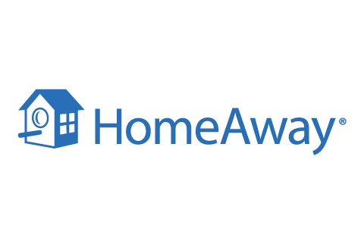
There are quite a few commercials now for HomeAway, a website that allows you to stay in a person’s home for a price comparable to AirBnB.

Blogs
The Poor Traveler
I Am Aileen
Nomadic Matt
Blonde Abroad

