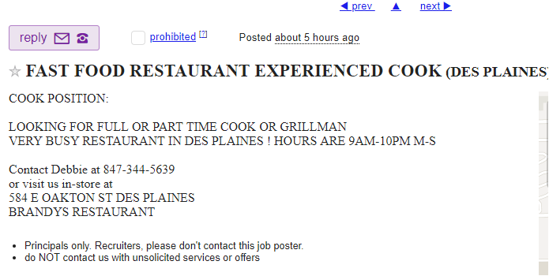

Filip Burns
4356 Ashton Lane
Austin, TX 78749
512-560-6719
fburnszzzzzz@gmail.com

Desired position: waiter

Jobs
Burger King 2018 – 2012
Evanston
Team member - Cashier
Open and close
Responsibilities may include meeting and greeting customers, taking food and drink orders, preparing food and drink orders, answering questions about menu, policy, and services, and providing excellent customer care. Burger King team members also assume the responsibility of maintaining a cleanly work environment.

Bob’s Burger 2012 – 2015
Short order cook
- Clean food preparation equipment, work areas, and counters or tables.
- Plan work on orders so that items served together are finished at the same time.
- Grill, cook, and fry foods such as french fries, eggs, and pancakes.
- Take orders from customers and cook foods requiring short preparation times, according to customer requirements.
- Grill and garnish hamburgers or other meats such as steaks and chops.
- Complete orders from steam tables, placing food on plates and serving customers at tables or counters.
- Perform simple food preparation tasks such as making sandwiches, carving meats, and brewing coffee.
- Order supplies and stock them on shelves.

Uptown Funk 2015 – current
Chicago, IL
- Cleans food preparation areas as determined by law and company policy
- Prepares foods to the specifications of the client
- Prepares food before the arrival of guests
- Makes adjustments to food items to accommodate guests with allergies or specific diet concerns
- Manages other employees in the kitchen
- Seasons food according to recipes or company needs
- Orders ingredients and spices as needed
- Operates various kitchen appliance such as a blender, oven, grill, or stand mixer
- Portions, arranges, and garnishes food based on client preference
- Devises new recipes
- Keeps records and accounts of food purchases
- Orders new menu items for specials or cheap deals

Benedicta Newell
4521 Ingram Street
Dayton, OH
45407
937-501-6356 937-414-1118
bnewelzzzzz@gmail.com
Desired position: computer programmer

Amador Macek
1727 Kessla Way
Ulm, Montana 59485
843-324-5752 406-788-5673
amacekzzzzz@gmail.com

Desired position: High school math teacher

