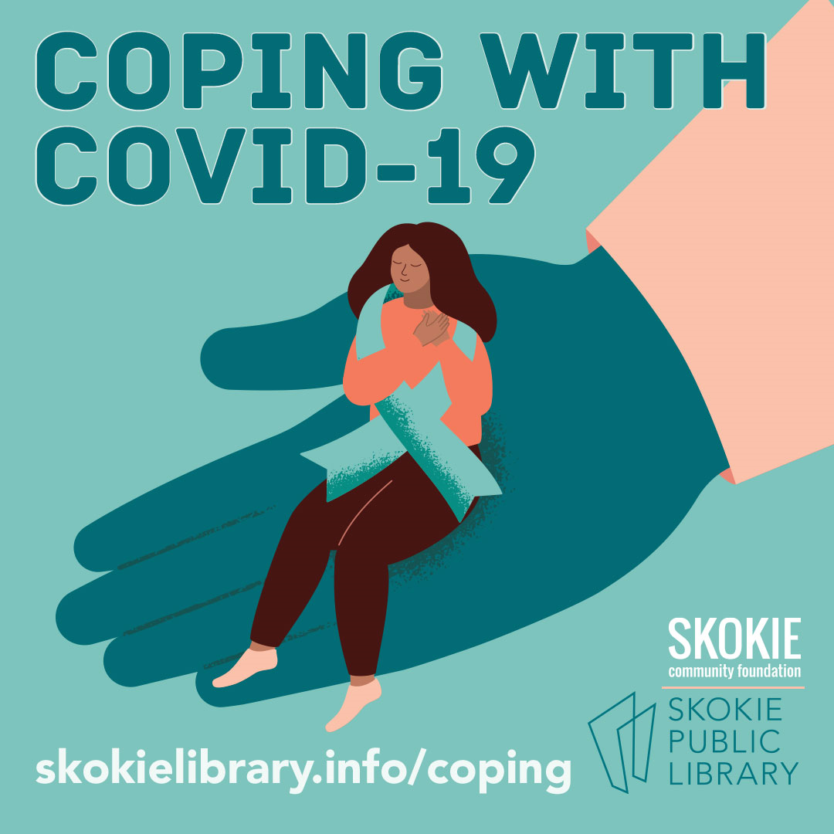

Coping with COVID-19 Resources
November 2020

Click on the links below to find program materials and additional resources on the following topics:

- General information on COVID-19 and community resources

- Taking care of yourself

- Supporting children ages 0-14

- Supporting young adults in high school and college

- Active adults staying connected--older adults

- Creating Community Connection

General information on COVID-19

Program Materials:

Illinois COVID-19 Update Keynote Presentation by Dr. Catherine Counard, IDPH

Coping with COVID Presentation by Cordelia Loots-Gollin, Turning Point

Community Resources:

Village of Skokie’s COVID-19 Response
Everything from current data trends, to how to get help, to information for local businesses.

Human Services Directory for Niles Township 2020
A comprehensive list of services compiled by LAN 41, including health care, mental health, financial assistance, hotlines, food, housing, seniors services, legal aid, and other resources.

Erie Family Health Centers
Appointments, testing, other COVID-19 and healthcare resources and information, for people with and without insurance. Bilingual services.

Heartland Health Centers
Appointments, testing, other COVID-19 and healthcare resources and information, for people with and without insurance. Bilingual services.

Free meals for students living in Niles Township (November-December 2020 schedule)

NorthShore University Health System COVID-19 Information and Resources
NorthShore University Health System’s response to COVID-19, FAQ’s, Safety Toolkit and more.

Online Resources:

Centers for Disease Control and Prevention
Guidance on a wide range of topics related to COVID-19 and the impact on daily life.

Health Equity Considerations and Racial and Ethnic Minority Groups
CDC information on factors that contribute to increased risk, and links to COVID-19 racial data.

Holiday Season Safety Tips
Guidance on travel, meals, overnight guests, etc. from Illinois Department of Public Health.

Johns Hopkins Coronavirus Resource Center
Continuously updated source of COVID-19 data and expert guidance.

Taking care of yourself

Program Materials:

Chair Yoga, Relaxation Exercises, and Deep Breathing by Sharon Kater, Turning Point

Community Resources:

Turning Point Crisis Support Line: 1-800-953-0051/dial 0 Monday-Friday, 9 am-2 pm
Ask to speak to a crisis worker.

Illinois Call 4 Calm Text Line: text TALK to 552020 for English or HABLAR for Spanish for free, anonymous help 24/7 to link to local emotional support anywhere in the state of Illinois.

Mental Health Resources in Chicago’s Northern Suburbs
See Resources tab for emergency, outpatient, partial hospitalization, and substance abuse services, in addition to support groups, and general mental health.

Online Resources:

Coping With the Coronavirus Crisis: Taking Care of Yourself

Tips from the Child Mind Institute, an independent, national nonprofit dedicated to transforming the lives of children and families struggling with mental health and learning disorders.
Coping with stress during infectious disease outbreaks
Recommendations from Substance Abuse and Mental Health Services Administration

COVID-19 During Winter: 8 Things You Can Do to Mentally Prepare
The Mayo Clinic shares how preparation can help ease the transition from fall into winter and help you feel mentally ready for a pandemic winter.

COVID-19 Mental Health Resources
Blogs, webinars, screening tools and more compiled by Mental Health America

Five Minute Medication: Mindfulness of Thoughts

Mental Health, COV-Course: A Multidisciplinary Approach to Understanding the Pandemic

Dr. Tara Powell and Dr. Karen Tabb from the University of Illinois discuss the mental health impact of collective trauma events, including COVID-19, and how to overcome stress.

Supporting children ages 0-14

Program Materials:

Supporting Children Ages 0-14, presentation by Bryan Kelly-D69 and Khemarey Khoeun

SEL at Home: Family Resources and Self-Care Strategies

Tips and Strategies:
- CASEL Website
- Schedule specific time for kids are able to connect and engage with each other
- Create PODS of families to allow for socialization interactions to take place

Community Resources:

Turning Point Parent Support Line: 1-800-953-0051/dial 0 Monday-Friday, 9 am-2 pm
Strategies for responding to challenging behaviors, tips for self-regulation and self-care, referrals and resources for ongoing mental health support. Ask to speak to a crisis worker.

Parents Helping Parents 1-800-632-8188 24/7, 7 days a week
Trained volunteer counselors offer a way to relieve stress in an environment which is non-judgmental along with being sympathetic. Translation services provided.

Online Resources:

COVID-19 Parental Resources Kit – Childhood
Advice from the CDC for parents, caregivers and others supporting the social, emotional and mental well-being of children ages 6-12 during Covid-19.

How to Talk to Your Kids about Covid-19
Mayo Clinic shares practical advice for starting conversations with kids about Covid-19, talking points to discuss, teaching kids how to stay safe, strategies to help kids cope and dealing with family exposure to the virus.

Tips for caregivers, parents, and teachers during infectious disease outbreaks from SAMSA.

How to support children during the COVID-19 outbreak
Recommendations from the Center on the Developing Child Harvard Institute

Supporting young adults in high school and college

Program Materials:

E.S.S.E.N.C.E of Adolescence: What happens to the brain during adolescence, and tips during the pandemic

Hand Model of the Brain

Tips and Strategies:
- Label/name emotions you’re experiencing in a moment of dysregulation (stress). This can help your brain get “back on line” in order to use your brain’s prefrontal cortex and use rational thinking / reasoning.
- Parents may be able to recognize when their child has “flipped their lid” and can help their child name their emotion.
- How to collaborate with your child’s school:
  - Technology barriers to e-learning: talk to the school to get tech issues met.
  - To communicate with your child’s school start with their academic counselor. They are the point person to the Dean, school social worker, and psychologist.
  - Learn your child’s specific learning style.
- Help your child feel like they’re not alone and this is a difficult time for everyone.

Community Resources:

Turning Point Parent Support Line: 1-800-953-0051/dial 0, Monday-Friday, 9 am-2 pm
Strategies for responding to challenging behaviors, tips for self-regulation and self-care, referrals and resources for ongoing mental health support. Ask to speak to a crisis worker.

Response for Teens by JCFS
Resources, counseling, blogs, support groups and more.

Online Resources:

COVID-19 Parental Resources Kit – Young Adulthood
Advice from the CDC for parents, caregivers and others supporting the social, emotional and mental well-being of young adults during Covid-19.

Support for Teens and Young Adults
The CDC shares information about the virus and ideas for teens and young adults to manage their stress, steps for coping with grief, and resources for mental health support and suicide prevention.

Supporting teenagers and young adults during the Coronavirus crisis
Tips from the Child Mind Institute is an independent, national nonprofit dedicated to transforming the lives of children and families struggling with mental health and learning disorders.

Active Adults Staying Connected: Resources for Older Adults

Program Materials:

Staying Connected by Jon Marquardt, Crystal Haben, and Aryn Fletcher--Skokie Park District

Community Resources:

CJE Senior Life Cyber Club
Online services for positive aging, including live and recorded activities for a range of interests such as wellness, fitness, mindfulness, cultural activities and instructional Lifenote videos and articles on a range of useful topics.

Mather Telephone Topics
Dial into daily programs on wellness, education, discussion topics, music reviews and live performances.

Senior Connections
Seniors are paired up with volunteers for regular conversations and activities.

Skokie Park District Recreational Activities
Weekly & monthly in-person activities including walking clubs, exercise classes, luncheons, bingo, movies and more!

Online Resources:

CDC Older Adults and COVID-19
Learn about the risks of COVID-19, and engage in activities and discover ways to stay healthy, including tips, videos and articles.

How to Stay Connected During Coronavirus Social Distancing
A short video from AARP providing tips and resources for staying connected during Covid-19 social distancing.

National Council on Aging (NCOA) Covid-19 Resources for Older Adults and Caregivers
Resources and articles about getting help, finding support, and staying safe and connected.
Creating Community Connection

Tips and Strategies:
- Put flyers around your block inviting people to get connected by email
- Simply pick up the phone and call a friend who shares a desire to make a change
- Just say “hi” to everyone out on walks--create a human connection with a smile
- Reach out with small acts of kindness
- Share your gifts and talents through a class on Zoom for friends
- Have a standing time to meet with others--create a routine
  - Set time for everyone in the neighborhood to meet out in the parkway to wave
  - Weekly Zoom call with old high school friends from all over the country
- An ongoing group text
- Groups may go through phases, allowing different people to pick up the lead for various projects, based on their availability and interests/needs at the time

Community Resources:
Skokie Spirit Shines Through
Campaign highlighting Skokie residents who are contributing to a sense of community.

Skokie United
A community group whose mission is to bridge perspectives through dialogue, engagement, and education to build a diverse, equitable, and inclusive community for antiracist justice.

Suburban Solidarity Network
A mutual aid network run by volunteers in the northern suburbs of Chicago, who believe in sharing our resources, skills, and strengths to benefit our community.

Online Resources:
AmeriCorps: 10 Ways to Safely Help Your Community During Covid-19
Simple ways everyone can help their neighbors, family and friends during the pandemic, and lists of activities and project ideas individuals can use to help their community.

Give InKind
An online platform to help those who want to help others. This platform was used by Northshore University Healthsystem to help feed essential workers at hospital ER’s and COVID testing sites.

Teleparty
A new way to watch TV with your friends and family online. Teleparty is a browser extension for watching TV remotely with others, adding group chat to your favorite streaming sites.

Volunteer Match
An online service that brings people and causes together, including COVID-19-specific and virtual volunteering opportunities.

