DECEMBER 5, 2017 BY MARY ANNE

Kale Sambol & Spice-Rubbed Steak
Kale Sambol
(20 minutes, serves 8)
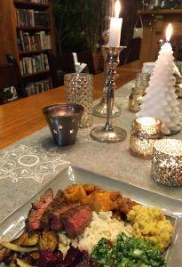
I had never been a big kale fan, but my friend, Roshani, completely converted me with her Aunty Indranee’s use of kale in this traditional sambol. In Sri Lanka, this would have been made with a native green, gotu kola, but kale is an excellent substitute (you can also try any other leafy greens, like beet greens, mustard greens, or rainbow chard).
For this preparation, kale is chopped small and tenderized with lime juice. When mixed with the coconut, tomatoes, sugar, and salt, the result is a tasty and addictive sambol that has become an essential component to many of our meals — if I make a meat curry now, I almost always make kale sambol to accompany it, and will often eat more sambol than curry. I’d have it with a little rice, but Kevin likes to just have beef curry and kale sambol together in a bowl, or with steak on a plate, which is also delicious.
1 bunch kale, leaves stripped off (stems discarded)
1 medium onion, minced
1 cup shredded unsweetened coconut
1-2 cups cherry tomatoes, chopped
Juice of 2 small limes (about 2-3 TBL)
1-2 TBL sugar
1 tsp fine salt
- Pulse kale in food processor until completely shredded into small bits.
- Add onion, coconut, tomato, lime juice, sugar, salt. Mix thoroughly.
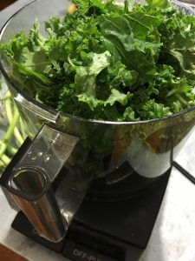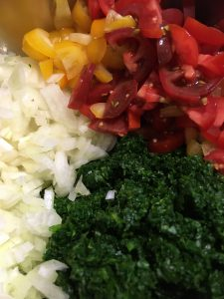
Can be served immediately, but best if allowed to sit and blend for an hour or so. Will keep in fridge for a good week—refresh with a little extra lime juice as needed.
Grilled Spice-Rubbed Steak
2 lbs. flank steak, cut into a few pieces against the grain
3 garlic cloves
1.5 t. kosher salt
2 T vegetable oil
3 t. Sri Lankan dark roasted curry powder
1 t. black pepper
1. Mince garlic and mash to a paste with salt. Add oil and spices and stir to a paste. Pat steak dry, then rub all over with paste (easiest with your clean hand). Marinate steak at least two hours, or longer, up to a day.
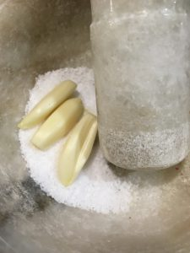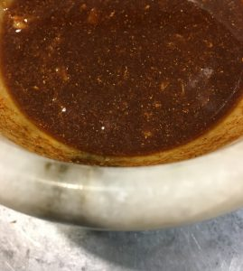
2. Heat grill to medium-high, and grill steak on lightly-oiled grill rack, uncovered, turning over once, 6-8 minutes total for medium-rare.
3. Let rest 5 minutes, then cut steak diagonally across grain into 1/4-inch-thick slices.
