MARCH 6, 2019 BY MARY ANNE

Ginger-Garlic Chicken
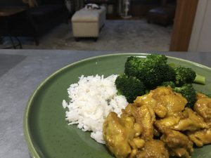(30-90 minutes, serves 6-8)
The timing on this is so variable because you can either do it the long way described below, the way my mother recommends, which is definitely a bit tastier — or you can do a much faster version, where you mix the spices with the chicken, skip the marinating, and then just sauté the chicken in the pan on medium-high until cooked through and serve. I use both methods, mostly depending on how much of a hurry I’m in. Regardless of which method you use, this dish is best served fresh; if it sits, the chicken will tend to dry up and not be as tasty.
NOTE: This is my daughter’s favorite chicken dish, and one she always greets with delight; she started eating it when she was about five, with no added chili powder. Over time, I’ve added a little more chili powder when feeding it to both kids, serving with milk to help them along; you can also use black pepper if you’d prefer.
1 heaping tsp ginger powder
1 heaping tsp garlic powder
1 heaping tsp turmeric
1 tsp salt
12 chicken thighs, about 2 lbs., deboned and cut bite-size
vegetable oil for frying
1/2 to 2 heaping tsp red chili powder (to taste, optional)
1. Mix first four spices in a large bowl; add chicken pieces and rub with your hands until well coated. Marinate 1/2 hour
2. Heat oil on high; add chili powder (if using) and cook 15 seconds, stirring.
3. Add chicken and sear on high, turning to brown all sides.
4. Reduce heat to low and cover; cook approximately 15-20 minutes, until meat is cooked through.
5. Uncover and cook until all the liquid is gone.
6. Tilt pan and push chicken pieces to one side; allow excess oil to drain to one side for 5 minutes. Remove chicken to dish and serve hot.

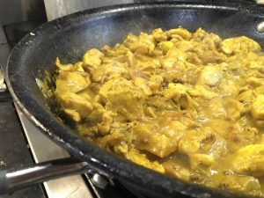
NOTE: If reheating a day or two later, I recommend reheating in a pan with a little coconut milk; just simmer 5-10 minutes, enough for the milk to thicken with the spices into a nice sauce. Or serve dry chicken with a nice coconut-milky vegetable curry, like carrot or beetroot curry.

