What Is Cyberpunk?
Saturday, February 22, 2020
2–3 pm

- What is cyberpunk?
- Cyberpunk is a subgenre of science fiction that features advanced science and technology in a gritty, dystopian future.

- Popular cyberpunk novels:
Neuromancer  By William Gibson | Altered Carbon  By Richard K. Morgan | Do Androids Dream of Electric Sheep  By Philip K. Dick | Moxyland  By Lauren Beukes
Trouble and her friends  By Melissa Scott | The Windup Girl  By Paolo Bacigalupi | Want  By Cindy Pon | Snow Crash  By Neil Stephenson
Ready Player One By Ernest Cline | Ghost in The Shell  By Massamune Shirow | Cyberpunk  By Bruce Bethke | Accelerando  By Charles Stross
Down and Out in the Magic Kingdom  By Cory Doctorow | Hardwired  By Walter Jon Williams | Blade Runner  By Philip K. Dick | Akira  By Katsuhiro Otomo

- Goodreads list of cyberpunk books: https://www.goodreads.com/shelf/show/cyberpunk
- Additional list of cyberpunk books: https://bookriot.com/2018/04/26/cyberpunk-books/

- Learn more about cyberpunk:
- What is Cyberpunk? An introduction to the cyberpunk genre: https://www.makeuseof.com/tag/cyberpunk-introduction-sci-fi-genre/

- Cyberpunk is now and no one knows what to do with it:
https://bit.ly/38bRdTz

- Cyberpunk video games you should play right now.
Remember Me  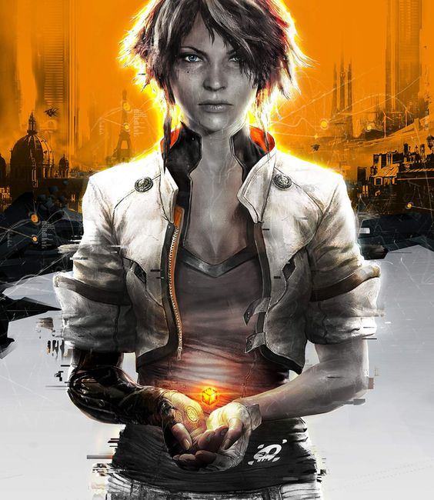  Imagine if your personal memories could be digitized, sold or altered. Remember me is an interesting cyberpunk game I had the chance to play. It has solid platforming and melee combat. On top of that, there are multiple segments in the game where you’re able to alter someone’s memories to find secrets and defeat enemies. | Transistor  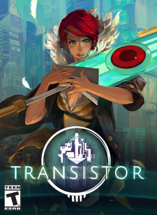  Transistor fits more into the dystopian setting of cyberpunk. You play as red, an opera singer who has lost her voice, she finds a powerful talking sword and you must travel to different parts of a large dystopian city, gaining unique abilities and defeating enemies to eventually retrieve Red’s stolen voice.
Observer  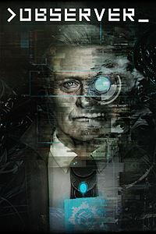  I never thought horror and cyberpunk could co-exist but here we are. In this game you play as a detective and you’re able to jack into your suspects mind. At times you’ll be really excited to see what secrets you’ll find inside your suspects memories. Other times you’ll want to leave their memories as soon as possible. | Deus Ex: Human Revolution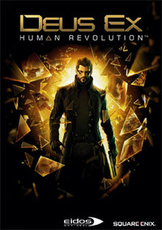  Deus Ex is everything I could ever ask for in a cyberpunk video game. Incredible story, fantastic cast of characters ‘awesome cybernetic powers and weapons, hacking and conspiracy theories, I think this game was secretly made just for me. Play Deus Ex. You’ll thank me later.
- Full list of cyberpunk games:
https://www.gamesradar.com/best-cyberpunk-games/

- Types of cyberpunk

- Steampunk
Steampunk’s probably the most famous subgenre to come out of cyberpunk. Steampunk mainly focuses on Victorian era clothing and steam powered technology and machinery.

- Biopunk
Biopunk and cyberpunk tend to have similar characteristics and themes so it’s easy to look at both in the same manner. However, biopunk focuses more on genetic engineering and cloning experimentation.

- Dieselpunk
Dieselpunk is similar to steampunk. Both have weaponry that is powered by machine- fueled technology; however, the steampunk genre revolves around technology from early 1940s and 1950s. Dieselpunk focuses more on gigantic metal machinery, like metal airplanes, that are powered by diesel engines.

- Forestpunk
Alright, I made this one up. Feel free to let me know if it actually exists.

