Microsoft Word 2016 for Beginners
Tuesday, August 22, 2017
3:00 pm - 4:30 pm

- What is Microsoft Word 2016?
  - Microsoft Word is a word processor. It allows you to create a variety of document, including letters, resumes, lists, and much more. Word allows you to save documents to come back to later and open a saved document to edit.
- Where to learn more:
  - Lynda.com—create a free account with your Skokie Library card.
  - Goodwill Free Learning—http://www.gcflearnfree.org/word2016
  - Microsoft Support website—https://support.office.com/en-us/word
- Learn to type, free and online:
  - http://typingclub.com
  - http://www.how-to-type.com

Interface Tour

- The Start Screen—choose a new document, saved file, or a template in the Start Menu.
Search for a pre-made template.
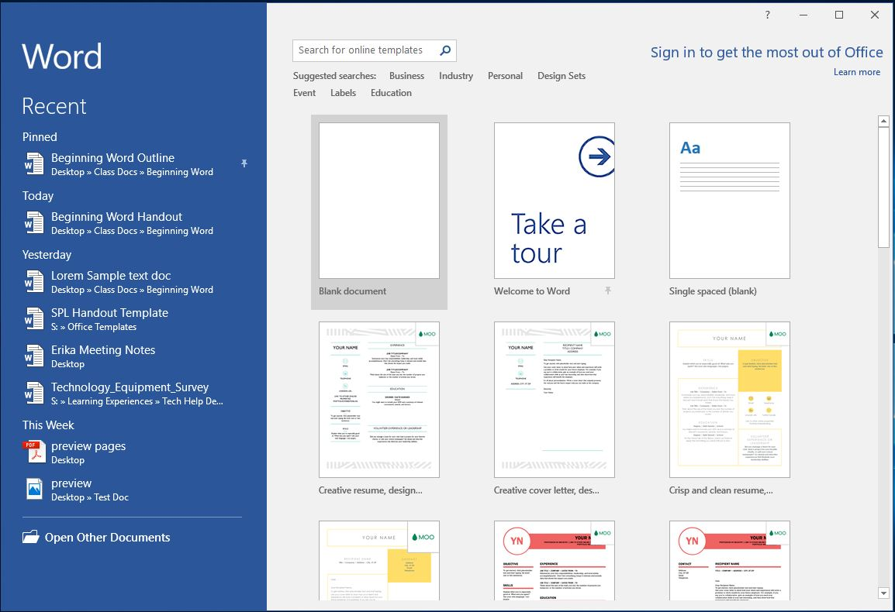
Sign in to your Microsoft account to access OneDrive or Office Online.
Search for a featured template.
Open a blank new document.
Find and open a recent document.

- Backstage View (File Menu)—the File Menu gives you options for saving, opening, and sharing.
Go back to your document.
Start a new document

Open a saved document.
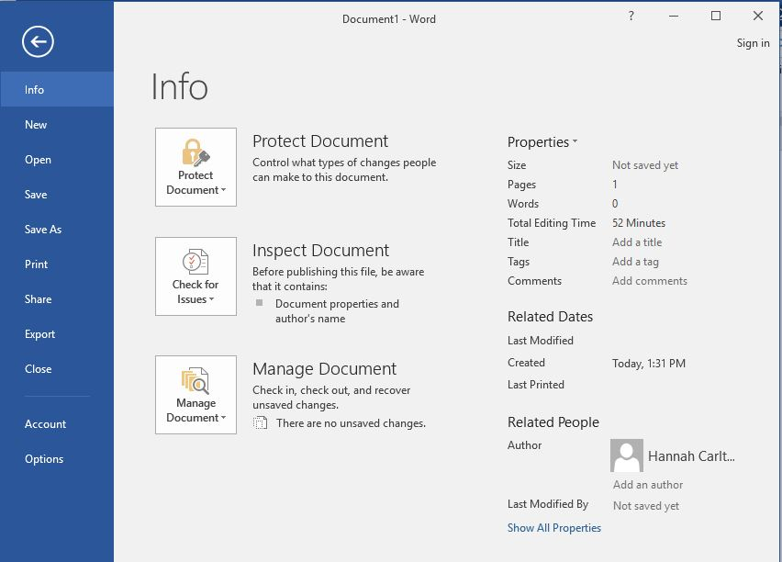
A Quick Note:

There are often several different ways to accomplish the same task in Word. For example, you can save a document in several different ways:
- Click the Save command in the Quick Access Toolbar.
- Go to File and click Save or Save As.
- Press the Control (Ctrl) and S keys simultaneously.
Each of these three options will save your document. Choose an option that works for you and that you can remember easily, but don’t worry about learning every single way to accomplish a task in Word. One way will do the trick!
Print your document.
Save your document or Save As.
Share or change the file type of your document.
Customize your advanced settings in Word.
Recover documents and unsaved changes.
Review the properties of your document: file size, word count, pages, and more.
- MS Word Interface—create your document!
The name of your document appears at the top of the Window.
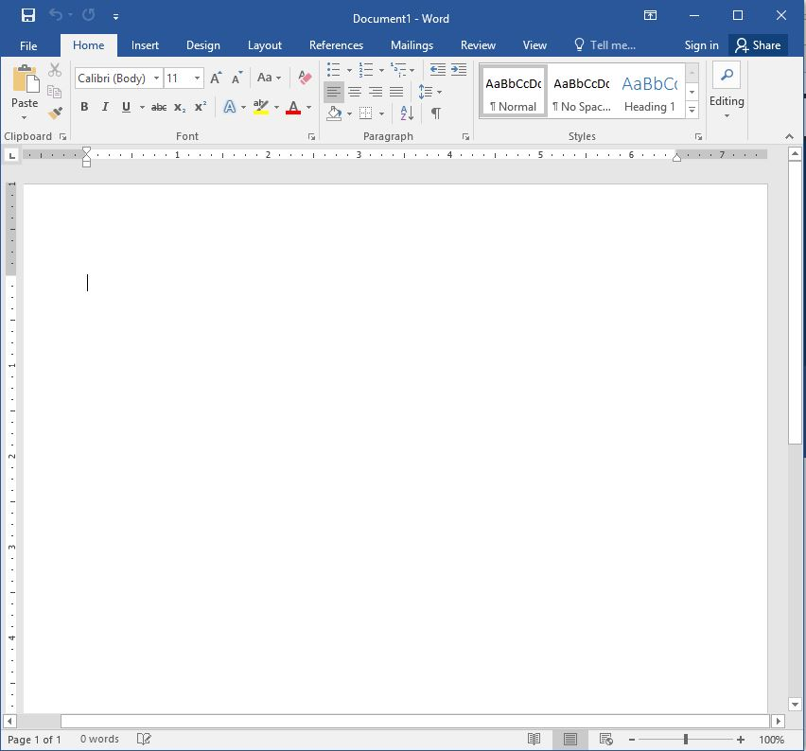
With the Tell me bar, search within Word.
See the dimensions of your document with the Ruler.
Scroll through your document with the Scroll Bar.
Work on your document in the Document Pane.
View page number and word. count.
Zoom and change page view.

- The Ribbon—the metaphor of the organization of the Ribbon is a filing system. Commands in the ribbon are sorted by purpose in different Tabs.
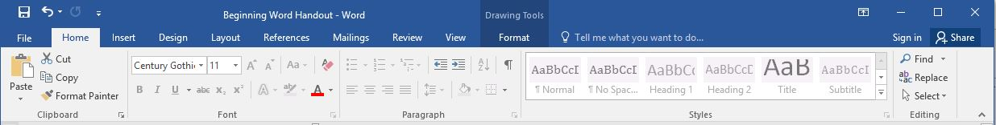
To learn more about any command, hover your mouse over it.
The Tabs in the Ribbon offer different groups of commands to customize your document.
Related commands are grouped together. To see more options, click the arrow in the lower right corner of the Group.

- The Home Tab

Find a word or phrase in you document or select blocks of text in Editing.
Change the alignment and spacing of your text in the Paragraph Group.
In the Font Group you can change the size, font, and color of your text—and much more!

- The Insert Tab
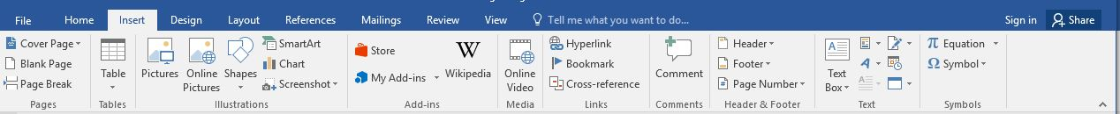
Insert a symbol.
Insert a header, footer, or page number.
Insert a picture from your computer or online.
Insert a new page or page break.

- The Review Tab

Check your spelling and grammar.
Change the language in Word.
Protect your document so that only you can make changes.

