A formula starts with an equal sign. Ex: =(D1+D2) or =(2+4)
A formula can use functions. Ex: =AVERAGE(A1:A40)

All Functions are Formulas. Not all Formulas are Functions.
You can identify functions if you see a reserved-word function name such as SUM.
You can mix formulas and functions in a cell.

From Excel 2013 All-in-One for Dummies:
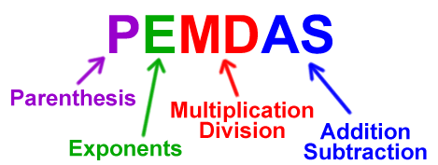
Figure 1 Excel follows math's Order of Operations
Type | Character | Operation | Example
Arithmetic | + (plus sign) | Addition | =A2+B3
 | – (minus sign) | Subtraction or negation | =A3–A2 or –C4
 | * (asterisk) | Multiplication | =A2*B3
 | / | Division | =B3/A2
 | % | Percent (dividing by 100) | =B3%
 | ^ | Exponentiation | =A2^3

Create first Formulas

Two methods:
- Can do this by typing an equal (=) sign and then type the formula in the formula bar.
- Can type the = sign, then click on the first cell, type an arithmetic sign, and then click on the second cell.

How do you know if a cell contains Data or a Formula (or Function)?
Click on the cell, if the Formula bar starts with an equal sign, it is a Formula

Create first Function

A function is a built-in operation, such as SUM(), AVERAGE() etc. Functions are always capitalized. Things that go between the parentheses are called the argument(s), and it must be the right type of data, etc. For example, you wouldn’t want to sum a person’s name, you’d want to sum a number.
A function is like a telephone – we enter a set of numbers and the phone connects us to another person. We don’t care about switches, copper wires, or any of the details about how this function is accomplished. Also, the phone will never cook us dinner nor do our taxes. It has one function.

At least 6 ways of entering a function:
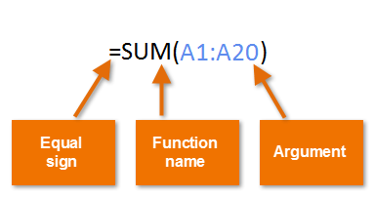
- Can do this by typing the Function in the formula bar, as written above.
- Can type =SUM then click on the first cell, drag the fill handle across or down to the end of range (notice the “marching green ants”). Release handle, click ENTER.
- Home > Editing (all the way on the right side) and the ∑ AutoSum drop down arrow. Select a commonly used function.
- Select a range of cells (one row or one column), then click on the Quick Analysis icon that pops up, then Totals. Select desired function.
- Formulas > Insert Function (or Shift + F3). In the Insert Function dialog box, type in some key word, such as count, or payment, and then click Enter. This will bring up a list of functions related to your search term. Best way to learn how to use a new formula (see next page for explanation).
- Formulas > Formula Library, and then browse for something useful. Click on something that seems close. This brings up the Insert Function Dialog box that gives a short description about that function.

Three ways (at least) to copy (or Fill) a Formula to another cell

- Enter formula in the first cell, click Enter, drag the fill handle to new location
- Preselect the entire range for the formula. Enter the formula in the first cell, and press <CNTL Enter> to populate the formula in the entire range.
- Define the range as a Table (advanced topic).

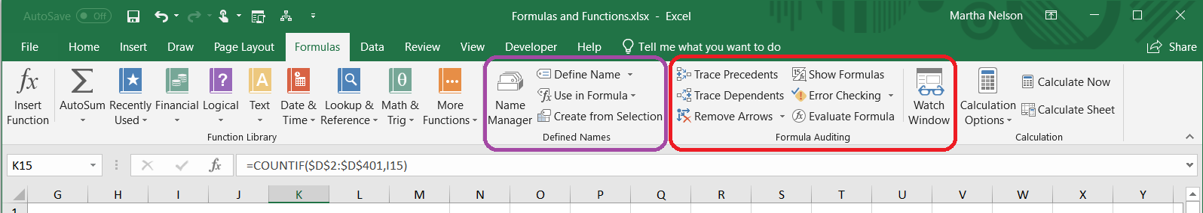

The Formula tab has many helpful options. Leftmost is the Insert Function button. Next, the Function Library section has “books” which hold the functions for that specialty. Ex: all functions relating to money are in the Financial book.

The Name Manager helps you figure out where important variables are kept.

Show Formulas - <Ctrl ~> or click on the Show Formula button on the Auditing section. This will toggle between two different ways of showing the worksheet: the regular way where the cells’ data already calculated or display the formulas.

The precedents buttons are a visual way to track what goes into or relies on specific cells.

Use Insert Function dialog box to search for and implement a Function
- Select a Cell
- Click on Insert Function button on Formulas Tab (far left side).
- Enter a search term, such as “loan repayment” to get a list of possible Functions.
- Click on a function (try PMT) to display Function Arguments dialog box. Move it so it isn’t covering your data.
- The Dialog box will walk you through which data needs to be fed to the PMT Function. Select cell or range of cells to fill in the Values of the arguments, the formula result will appear in the lower left corner of the dialog box.
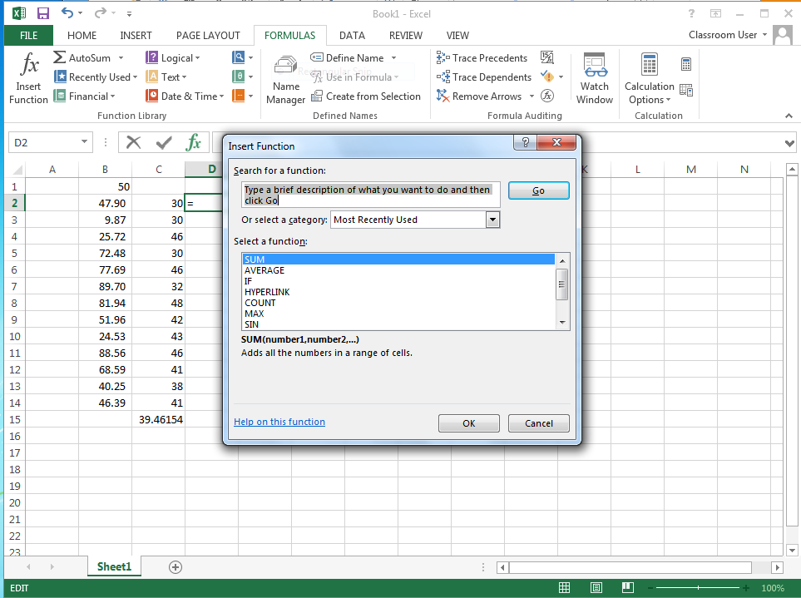 | 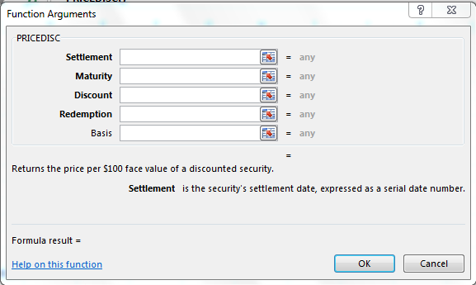

Error Messages:

#DIV/0! | The denominator is 0
#NAME? | Range Name doesn’t exist in a worksheet. Check for a typo.
#NULL! | When you enter a space instead of a comma to separate cell references
#NUM! | Wrong type of argument in a function, or a number is too big or small
#REF! | Invalid cell reference, happens with clumsy cut & pasting.
#VALUE! | Wrong type of argument in a function, or if you do math on text
##### | Not really an error message - the column is too narrow to display the field. Adjust column width to display cell.

References
There are 4 kinds of cell references, or ways to refer to cell’s address within a formula:
- Relative - the default. Copy a formula with the fill handle, and each row’s formula automatically changes the references. Ex: =SUM(A3:A6) fills as =SUM(B3:B6) and =SUM (C3:C6)

- Absolute - recognized by the $ sign, as in $A$3 or $A2. If you autofill something using an absolute reference, this field’s address will not change. When editing a formula, use F4 to toggle on the various combinations of Absolute referencing formats. Absolute references are useful to control variables - change just one field to update much data.
Please remember: if you autofill a formula and get super weird results, go first to check if you should be using absolute references or not.

- Defined names – give a name to a cell, and that name is used in formulas like an absolute referenced cell. Formulas>Define Name Ex: SalesGoals, MortgageRate, SalesTax are all easier to understand than a cell reference when used in a formula. Some users put all defined named variables on the first sheet of the workbook and document what it means to help maintain the workbook.

- Structured reference– used in Tables, advanced topic. A Table is an object with specific properties, and if your data is in a Table, you can refer to the fields using the header names, not just the cell references.
To make a table, select your data and Insert > Table. Now you can perform all the regular functions as well some new ones. Ex: =SUBTOTAL(102,[DOW]) Here DOW is a field header of a column of data. Notice it is not in parentheses but in brackets.

IF, SWITCH, SUMIF, COUNTIF
It is very common for formulas to get complicated – they nest inside each other, they test for errors, etc.

The IF function tests something and does one thing if it is TRUE, and another thing if it is FALSE.
=IF(logical test, [value_if_true], [value_if_false]

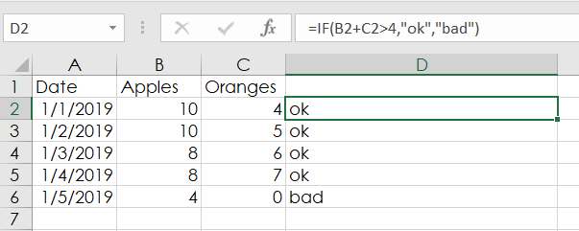
I recommend you start out with the Insert function button to be prompted for the correct parameters. Excel will add in the correct formatting for you and this is time consuming to fix.

Get the first piece to work first, then add more complicated logic.

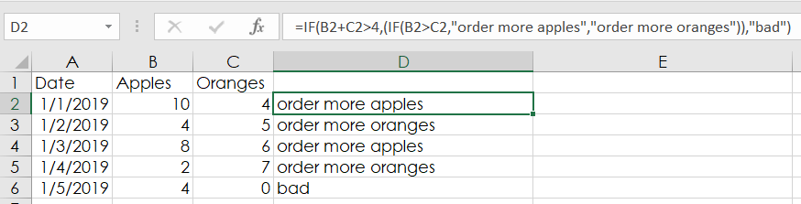
Next, start to nest your statements, be careful of balancing your parentheses and quotation marks.

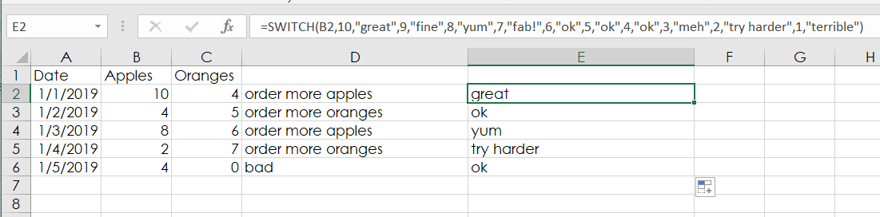
Switch is available in new versions of 2016 and Office 365. It returns a specific value you want to match against.

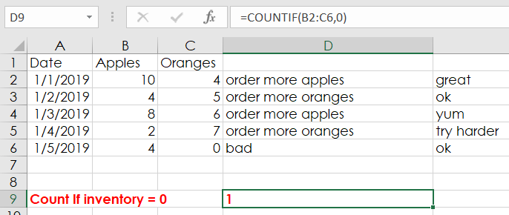
=COUNTIFS (range1, criteria1, [range2], [criteria2], ...)

