Facebook Basics

Facebook Facts:

- Facebook is a popular free social networking website launched in 2004 by founder Mark Zuckerberg.

- Facebook allows users to create profiles, upload photos and videos, send messages and share media.

- Facebook is reported to have 2.2 billion monthly active users worldwide as of January 2018.

- Facebook is constantly evolving. Features and controls change frequently. The company has altered the look and function of pages many times over the years.

Signing Up:

To register for a Facebook account you need:
- E-mail address or mobile phone

- Must be at least 13 years old

Go to www.facebook.com
If you see the signup form, fill out your name, email address or phone number, password, birthday and gender. If you don't see the form, click Sign Up, then fill out the form.
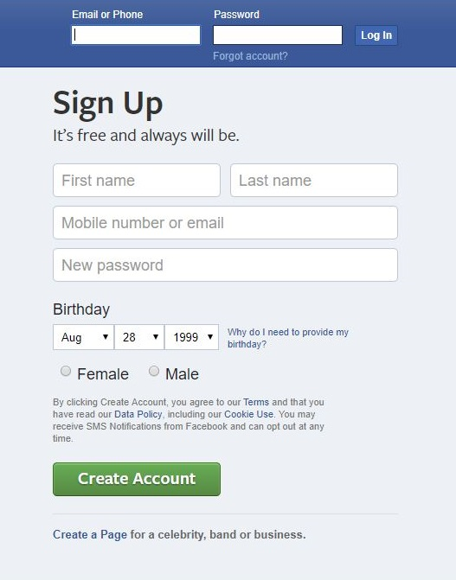
Once you create your account, you'll need to confirm your email address or phone number. Facebook will send you either an email or a text message to help you confirm your account.
If you already have a Facebook account, sign in here using your email address or phone number.

The Facebook Menu Bar:

Newsfeed
Messenger
Friend Requests
Notifications
Help
Wherever you end up within Facebook, the menu bar at the top of the window will give you the needed options to navigate Facebook—you can access your profile, newsfeed, settings, and more.
Profile

Profile Pages:

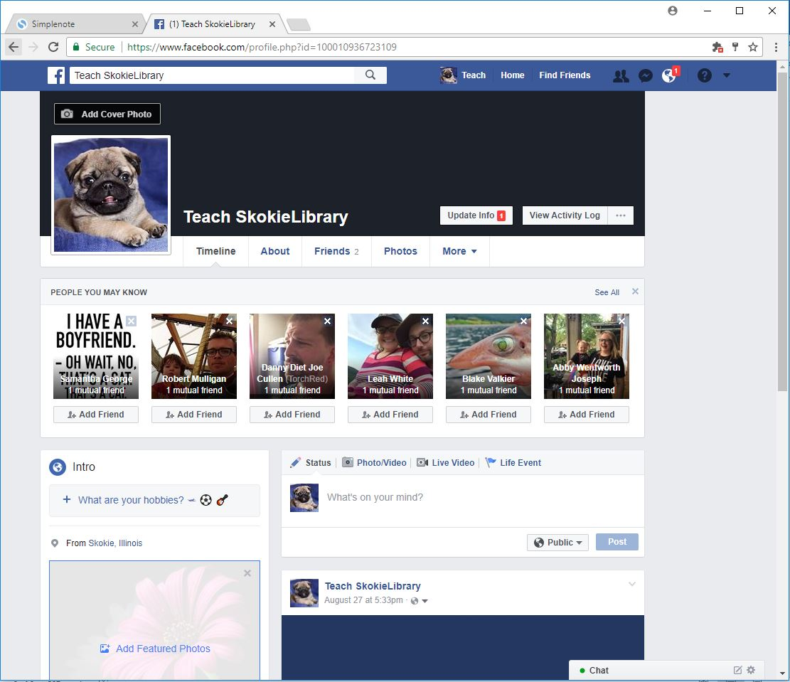
The Publisher appears on your News Feed and Timeline and allows you to post status updates—text photo or video.
People You May Know suggests friends based on mutual friends and shared networks. You do not have to friend any of them and can remove the field by clicking the X in the top right corner of the box.
Your Profile Picture and Cover Photo are some of the first things people will see on Facebook—choose images that present the online image you want.

All of your activity on Facebook—posts, photos, comments, and more—appear on your Timeline.

Home Page/News Feed:
To react to a post, click like or comment. To share it, click share and select the person or group with whom you want to share it.
See what your friends and followed groups, pages, and people are up to on you News Feed.

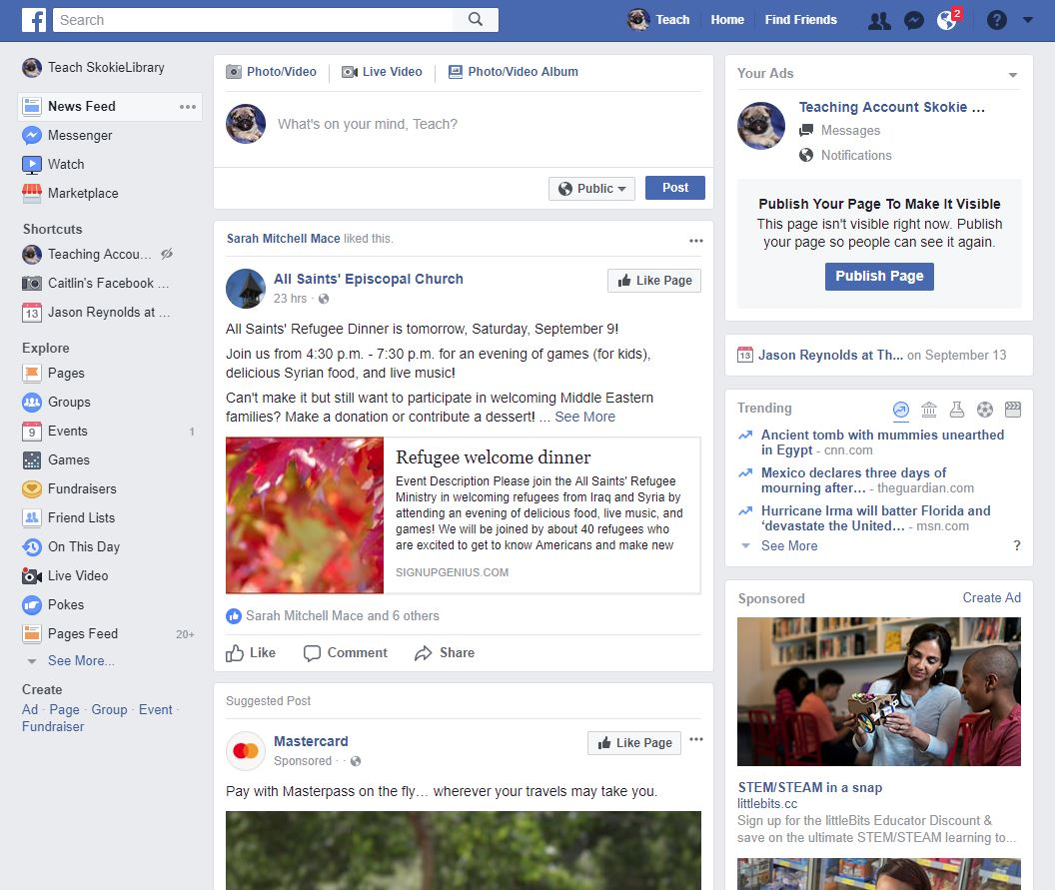
Review your history on Facebook with On This Day
Explore or create pages, events and groups through these shortcuts.
Create a friend list to make sharing posts with specific people easier.

Facebook Vocabulary:

There is some important vocabulary particularly associated with using Facebook. Below is a list of some of the most common and useful terms.

- News feed—a constantly updating list of posts from friends, Pages, and other connections you’ve made on Facebook.
- Timeline—your timeline shows all of your activity on Facebook: status updates, photos, comments, and more.

- Profile—your profile is like a mini biography and can include a range of basic information about you. Remember that you can choose most of what you share on your profile, and can change your privacy settings, but your name and profile picture will always be visible to everyone on Facebook.
- Status—a way to share events, thoughts, experiences, photos, and more with friends.
- Like—a way to let someone—or many people—know you like or approve of something. When you like something three things will happen:
- Anyone who can see the post will see that you liked it.
- There will be a post on your Timeline that you liked it.
- The person who posted will get a notification that you liked it.
- Tags—tags are a way to identify a person, place, thing, or idea in a post or photo.
- Friend—someone you are connected with on Facebook. When you add someone as a friend, they can see your profile and posts.
- Messages—the messages function allows you to send anyone on Facebook, even people who are not online, a private message. Messages function similarly to email, but are limited to people signed up for Facebook.
- Group—a group is a collection of people connected on Facebook who like or are interested in the same things. These can include clubs, books or authors, bands, neighborhoods, and more.
- Event—an event on Facebook is a great way to organize! You can post event information, invite people to attend, and keep people up to date on changes.
- Page—a profile for celebrities, brands, and businesses. Follow a page to be kept up to date on what they’re doing.
- Notification—you get notifications on Facebook when something happens that more-or-less directly involves you.
- Block—when you block someone, they will not be able to see your profile, send you friend requests, or send you messages.

Want to learn more?
- Goodwill Community Foundation—https://www.gcflearnfree.org/facebook101
- Techboomers—https://techboomers.com/p/facebook
- Digital Learn—https://www.digitallearn.org/courses/intro-to-facebook
- Facebook Help Center—https://www.facebook.com/help
- Facebook Privacy—https://www.facebook.com/privacy/explanation

